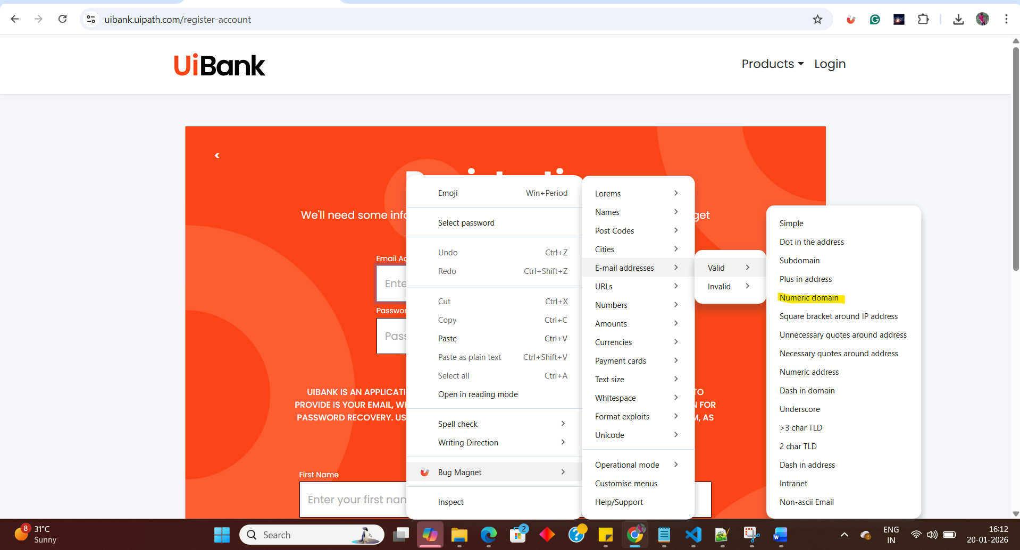

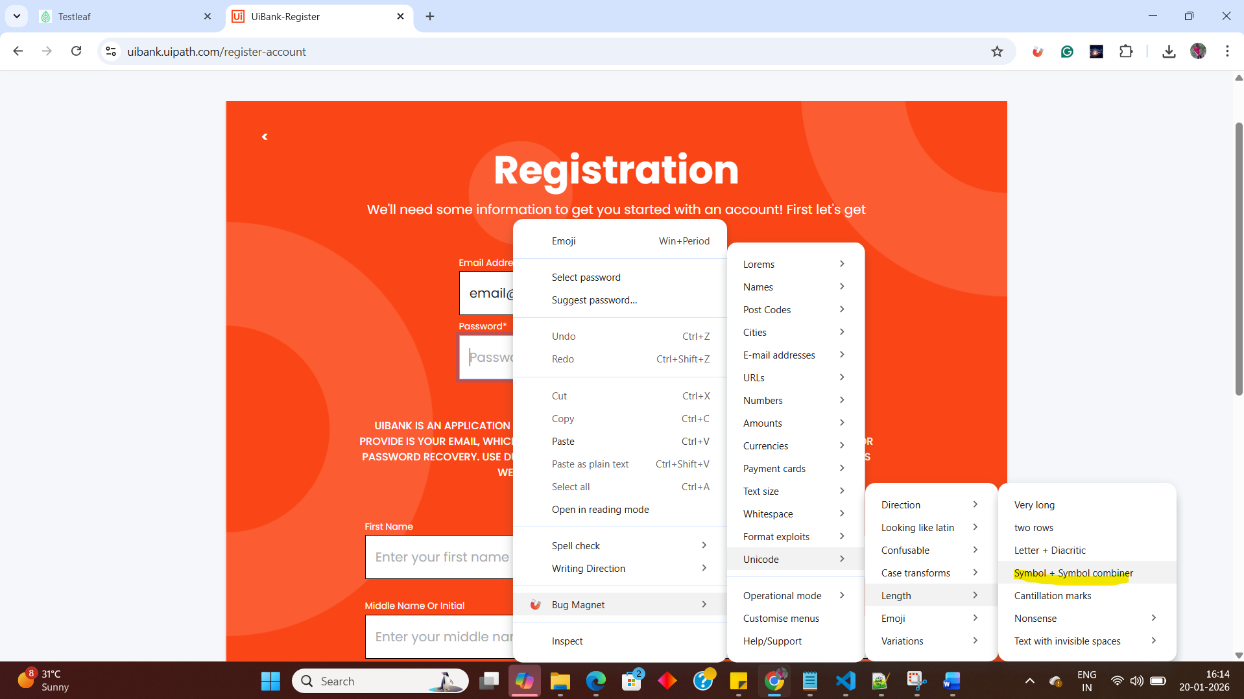

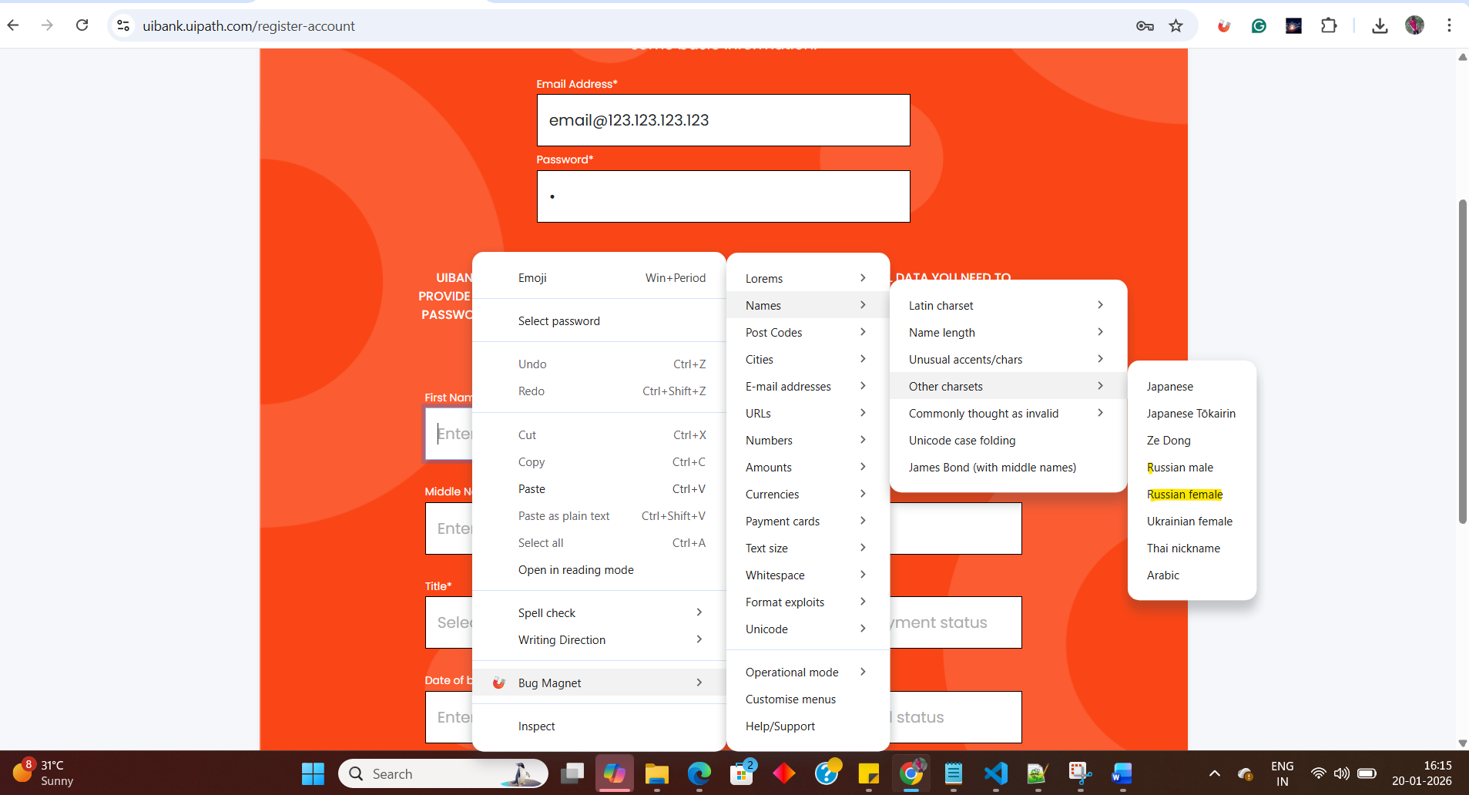

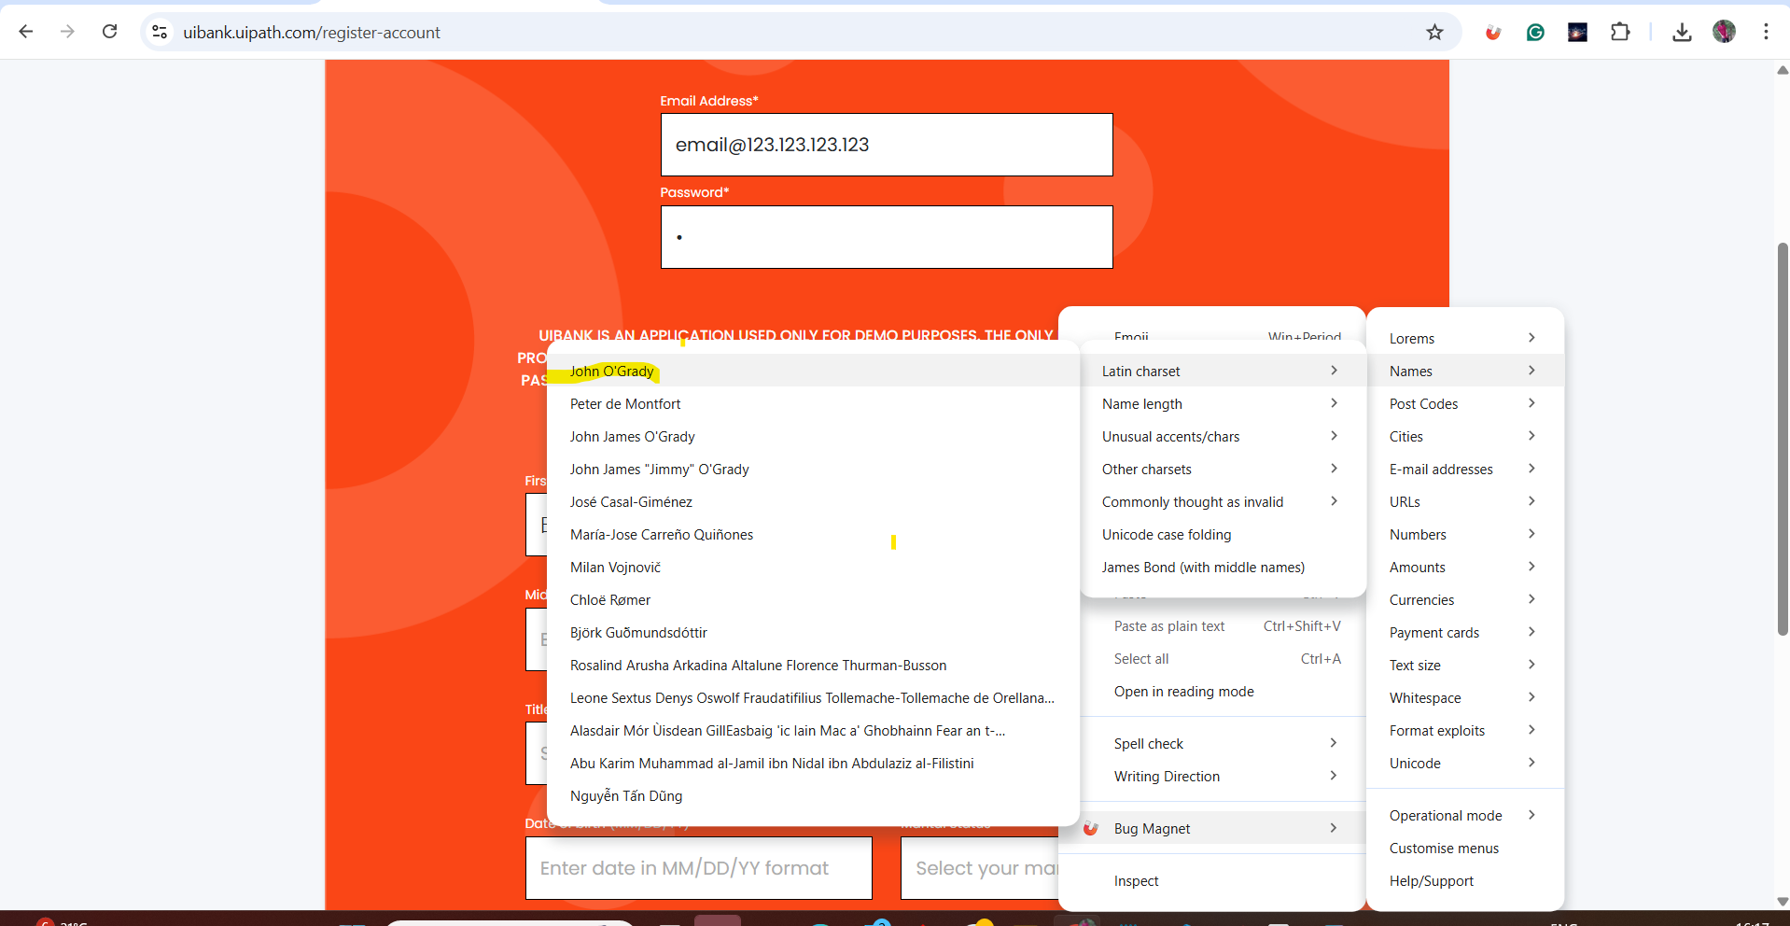

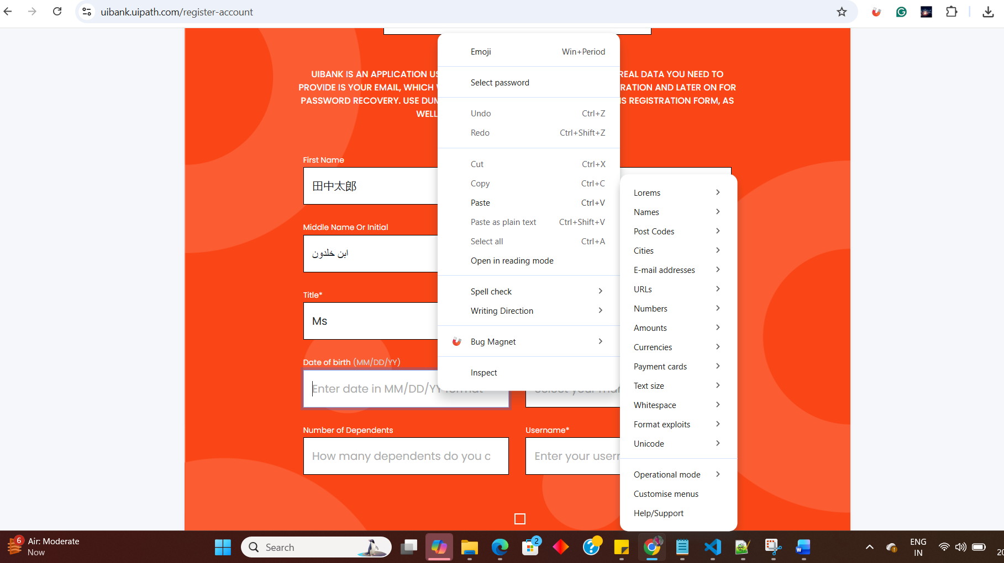

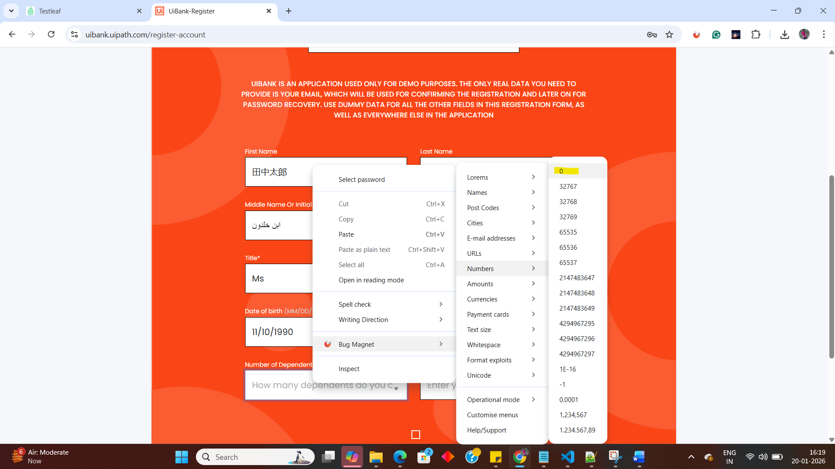

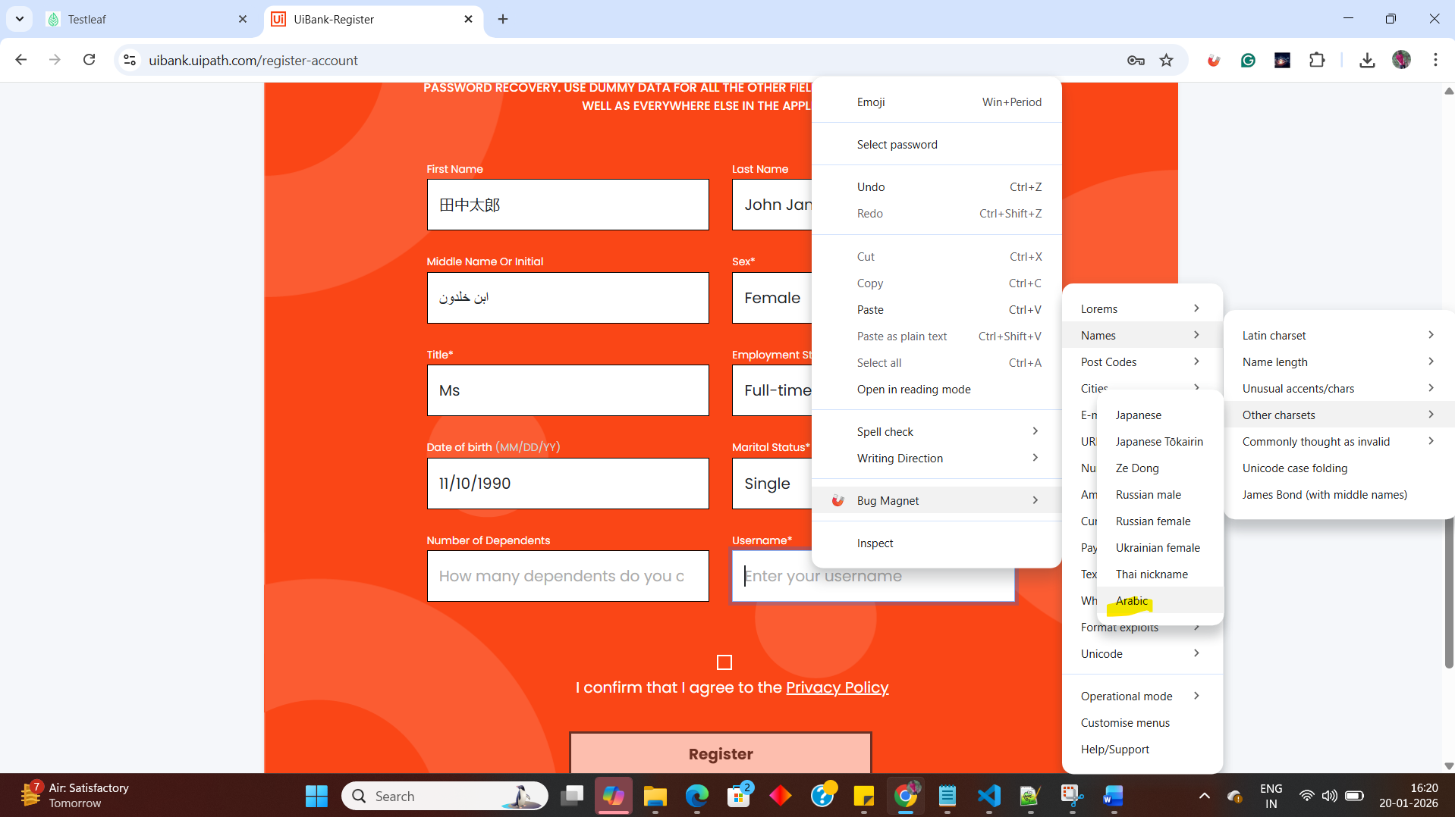

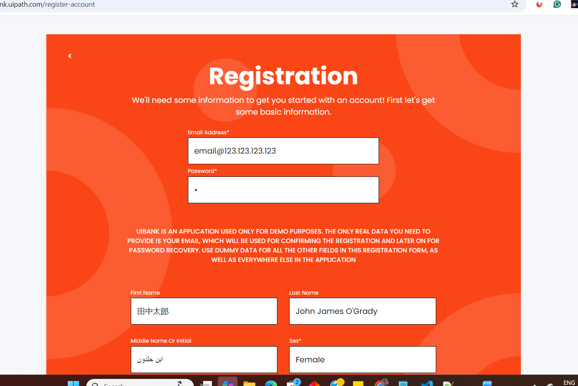

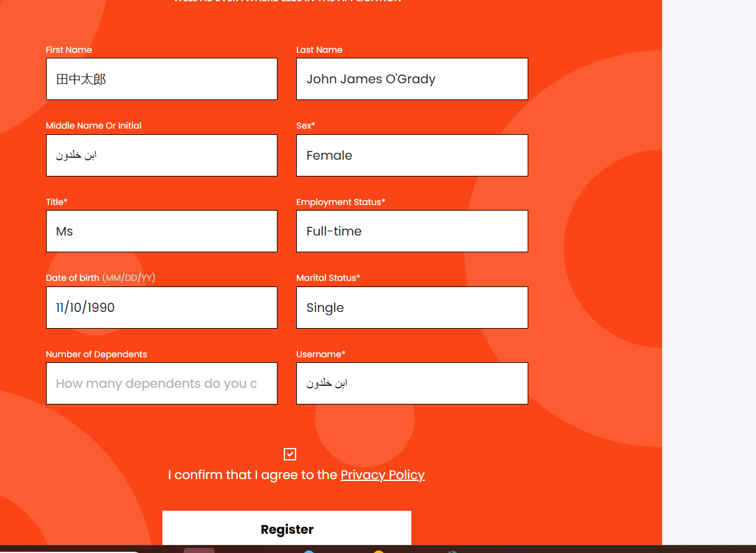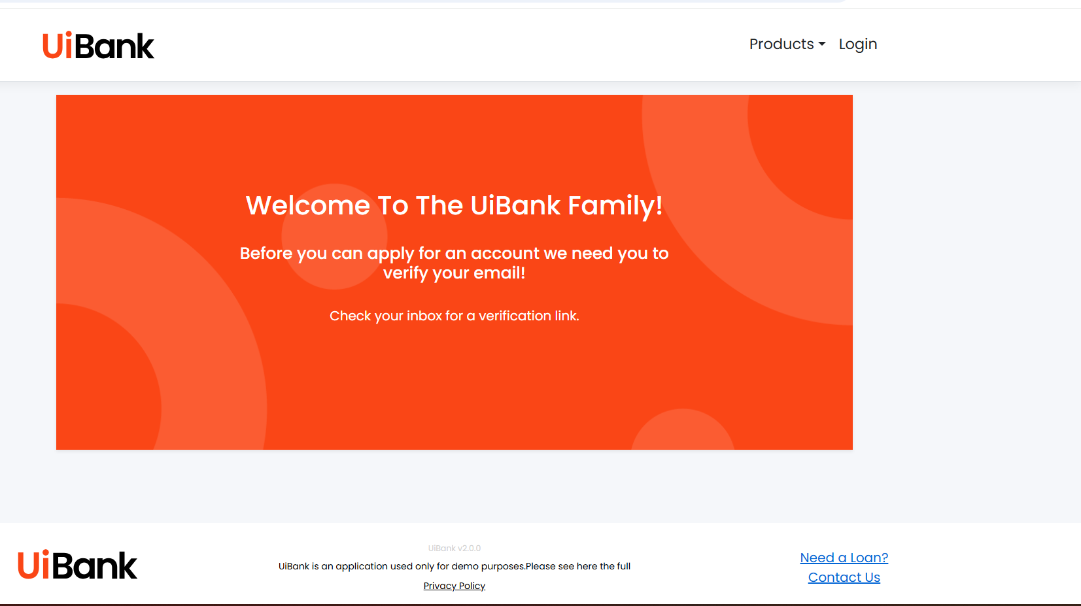

- Here some of the example I have given the field value for the registration in UI Bank which options having in bugmagnet

Here are typical BugMagnet test values you might choose for a “First Name” field to check validation and corner-case handling:

these help verify the field accepts reasonable real-world names.
- John
- Élise
- O’Connor
- Anne-Marie
- 张伟 (Chinese characters)
- Юлия (Cyrillic)
- Śrī (diacritics)

Use these to confirm the system supports realistic surname for Last name
- Smith
- Patel
- Garcia
- O’Connor
- D’Souza
- Anne-Marie
- Van Helsing
- De la Cruz
- Nguyễn
- Świątek
- Иванов (Cyrillic)
- 张 (Chinese)

Middle Initial (Most Common)
- A
- M
- R
- S
🔤 Initial with Dot
- A.
- M.
- R.
🧑 Middle Name (Full)
- Kumar
- Marie
- Elizabeth
- Singh
- Ali

- Sex* field does not have Bug magnet, because the field already has dropdown,
User should select the drop-down
Title* field does not have Bug magnet, because the field already has dropdown, User should select the drop-down
Employment Status* field does not have Bug magnet, because the field already has dropdown, User should select the drop-down
- Date of birth is having Bug Magnet but date format is not showing any calendar icon, in that case user should enter by manually
- Marital Status* field does not have Bug magnet, because the field already has dropdown, User should select the drop-down

Number of Dependents
Use these to verify normal system behavior.
- 0 (no dependents)
- 1
- 2
- 3
- 4
- 5

Valid Usernames
Use these to verify acceptable formats.
- johnsmith
- john_smith
- john.smith
- john-smith

